Final Project Report

Shopify your products online



Project Supervisor

<< Muhammad Luqman>>

Submitted By

MUHAMMAD YOUNUS RIAZ

Software Projects & Research Section,
Department of Computer Sciences,
Virtual University of Pakistan


CERTIFICATE

This is to certify that MUHAMMAD YOUNUS RIAZ has work on and completed their Software Project at Software & Research Projects Section, Department of Computer Sciences, Virtual University of Pakistan in partial fulfillment of the requirement for the degree of master’s in computer sciences under my guidance and supervision.

In our opinion, it is satisfactory and up to the mark and therefore fulfills the requirements of BS in Computer Sciences.

Supervisor / Internal Examiner
Muhammad Luqman
Supervisor,
Software Projects & Research Section,
Department of Computer Sciences
Virtual University of Pakistan

___________________
(Signature)

External Examiner/Subject Specialist
<<External Supervisor Name>>

___________________
(Signature)

Accepted By:

_____________
(For office use)

EXORDIUM

In the name of Allah, the Compassionate, the Merciful.

Praise be to Allah, Lord of Creation,
The Compassionate, the Merciful,
King of Judgment-day!

You alone we worship, and to You alone we pray for help,
Guide us to the straight path

The path of those who You have favored,

Not of those who have incurred Your wrath,
Nor of those who have gone astray.

DEDICATION

I was unable to complete my work without the support of my Kind advisor, my parents, and my friends.
I sincerely thanks to my parents to encourage me and thanks to my advisor who support me and guide me throughout the project activities, thanks a lot to everyone who give me good wishes all the time.
May Allah bless you all Ameen.

ACKNOWLEDGEMENT

I wish to express my sincere gratitude to
Sir Muhammad Luqman for providing me an opportunity to do my project in virtual university of Pakistan.
PREFACE

I am glad to present this project to my Advisor Muhammad Luqman.

This project is about online shopping. This includes functional and nonfunctional requirements and policies about online shopping system.
This project is prepared by MUHAMMAD YOUNUS RIAZ as a task of cs619 given by Advisor.
Hope to get good remarks in this project compilation.
IN SHA ALLAH…
TABLE OF CONTENTS

CHAPTER NO. 1
gathering & Analyzing info 09

1.1 Introduction 10

1.2 purpose 10

1.3 scope 11

1.4 definitions, acronyms and abbreviations 11

1.5 Project requirements 11

1.5.1 Functional Requirements 11

1.5.2 Non-Functional Requirements 12

1.6 use cases and usage scenarios

1.6.1 Use Case Diagrams 12

1.6.2 Usage Scenarios 13-16

1.7 Development Methodology

1.7.1 Chosen Methodology 17-19

1.7.2 Reasons for Chosen Methodology 20
1.7.2 Work Plan (Gantt Chart)
1.7.2 Project Schedule (Submission Calendar) 21

CHAPTER NO. 2
designing the project 22

2.1 Introduction 23

2.2 purpose 23

2.3 scope 23

2.4 definitions, acronyms and abbreviations 23

2.5 Architectural Representation (Architecture Diagram) 24

2.6 Dynamic Model: Sequence Diagrams 25-27

2.7 Object Model/Logical Model: Class Diagram 28

2.8 Database Model (Database Diagram) 29

2.9 Graphical User Interfaces 30-33

Chapter no.3
DEvelopment 34
3.1 Development plan (Architecture Diagram) 35

CHAPTER 1
Gathering & Analyzing Info

1.1 Introduction:

In the preliminary or general design, the features of the new system are specified. The costs of implementing these features and the benefits to be derived are estimated. If the project is still considered to be feasible, we move to the detailed design stage.
(Taken from internet)
“The design activity provides a roadmap to progressively transform the requirements through a number on stages into the final product by describing the structure of the system to be implemented.” (Source *handouts)
Requirements gathered are represented pictorially in this phase. In the gathered analysis we change our focus from “what to do” to “how to do”, which change the mode of work in software development team. A software designer designs this document in order to give a software development team an overall guidance of the architecture of the software project. A single vision is captured by all team of software developers they all focus on that vision. Mutually communication is possible due to gathered analysis. Once design document is created then we can reuse it for other requirement on the same lines.

1.2 purpose:

The purpose of this project was to develop a web application for purchasing clothing items online from a shop. This project helped us in gaining valuable information and practical knowledge on several topics like designing web pages using HTML & CSS usage of responsive templates, and management of database using MY SQLI. The entire system is secured. Also, the project helped us understanding about the development phases of a project and software development life cycle. We learned how to test different features of a project. This project has given us great satisfaction in having designed an application which can be implemented to any nearby shops or branded shops selling various kinds of products by simple modifications.

1.3 scope:

This system can be implemented to any shop in the locality or to multinational branded shops having retail outlet chains, especially for online shops. The system recommends a facility to accept the orders 24*7 and a home delivery system which can make customers happy. If shops are providing an online portal where their customers can enjoy easy shopping from anywhere, the shops won’t be losing any more customers to the trending online shops such as flipcart or ebay. it is easily accessible and always available.

1.4 definitions, acronyms and abbreviations

Definition:
Online shopping is getting popular because it facilitates the customer to buy desired product online. The main reason of online shopping emergence is that it saves time by providing the facility to place order online whatever is required and receive it on the doorstep easily.

Acronyms and abbreviations:
- HTML (Hyper Text Markup Language)
- CSS (Cascading Style Sheet)
- JS (JavaScript)
- PHP (PHP Hyper Text Markup Language)
- DBMS (Database Management System)
- Sublime Text 3 (Tool)

1.5 Project requirements

1.5.1 Functional Requirements

- User Registration/Sign Up, Sign In
There will be proper interfaces for user registration and Sign In for the following three types of the users of the website:
- Visitor (Unregistered User)
- Registered user (Customer / Client)
- Registered user (Administrator)

Roles of the users will be as follow:
- Visitor will be able to visit the website to search his/her relevant clothes on the website.
- A user registered as a Customer/ Client will be able to place order on the website.
- The Administrator (Admin) will have all the rights/privileges of information management regarding the clothes, stock management, as well as user management. Admin will approve the registration requests from the other users (customers / clients).

- Email Notification and Verification
An unregistered user will register him/her on the website. On submitting the registration information, an email notification will be sent with a confirmation link to the user’s given email ID. On confirmation through link, the Admin will approve the registration requests from users. An email notification will also be sent to the registered user on approval or rejection of any request.

- Admin Panel
There will be proper Admin Panel / Dashboard comprising of interactive interfaces through which the Admin will be able to add/ delete and update all information such as description, price, stock, images of Clothes. In addition, by using this Admin Panel, the Admin will be able to perform category management as well as user management (accepting /rejecting the user registration requests).

- Display of Information on the website
The fabric/clothing products name, quality, material, category, company name, thumbnail image, price and number of items available in stock, new Arrival, Sale (if any), contact us, complaints, feedback by the registered users etc. should be displayed on the website in proper design. On clicking the thumbnail, the website will maximize the fabric/product image.

- Placing Order on the Website
The website will allow the registered user(s) to make order against their selected items. There will be proper interfaces on the website in this regard. The user will first have to select the item to put into the shopping cart, and then will have to pass through any of the payment method i.e. through credit card or cash on delivery.

- Confirmation Email on transaction (Order Placing):
A confirmation email on successful transaction will be sent to the user’s provided email.

- Search Facility
The website will provide rich search feature through which all types of users should be able to search information on the website using different filters and keyword such as:
- Fabric Type
- Brand / Company Name
- Category Wise
- Price Wise
- New Arrival
- Sale
- Best Sellers
Admin will also be able to search the information by user IDs.

- Comments/Complaints/Feedback
The registered users will be able to submit feedback, complaints and comments against any product/item.

1.5.2 Non-Functional Requirements

Accessibility:
System must be accessible from all kind of web browser. It is accessible from both desktop and on mobile browser.

Availability:
System must available 24x7.

Maintainability
The maintenance of the website is very easy.

Usability:

This website will be self-descriptive, and user will be easily able purchase items online. This website will be user friendly website.

1.6 use cases and usage scenarios

1.6.1 Use Case Diagrams

Manage
Orders
Guest User
Signup

Search Product
View Stock

Secure Payments
View Product
Admin

Select Product
Manage Accounts
Reg. User

Checkout
Edit/View/delete

Feedback
Manage Products

Logout
Login
Login

1.6.2 Usage Scenarios

Use Case Title | Sign Up (Guest)
Use Case Id | 001
Actions | Click on sign up button  Fill the registration form with a valid email address and password  Click on create account button
Description | By signing up Guest will become a registered User, he will be able to select/purchase product
Pre-conditions | Open website , click on Registration button
Post-conditions | Success: User can Login to his Account and can purchase item on the website.  Failure: Error message is displayed
Exceptions | Problem with network connection  Email address already exists in database  Invalid email address  Invalid password
Author | MUHAMMAD YOUNUS RIAZ

Use Case Title | Sign in/Login (User and Admin)
Use Case Id | 002
Actions | Click sign in button  Enter email & password  Click sign in
Description | User and Admin both enter user id and password to sign in
Alternative Paths | Forgot password  Sign Up
Pre-conditions | User must have an account.
Post-conditions | Success: Signed in to the website.  Failure: User will be prompted again
Exceptions | Invalid email password combination
Author | MUHAMMAD YOUNUS RIAZ

Use Case Title | Sign out/Logout out (User and admin)
Use Case Id | 003
Actions | Click sign out button
Description | User and admin can sign out from the website
Alternative Paths | none
Pre-conditions | If a User and admin is signed in.
Post-conditions | Success: Signed out from the application  Failure: none
Exceptions | none
Author | MUHAMMAD YOUNUS RIAZ

Use Case Title | View product (User and Guest)
Use Case Id | 004
Actions | Click and the product to view it with detail
Description | Both User and Guest can View product, but only User can Add to cart/select it
Alternative Paths | None
Pre-conditions | Click on product
Post-conditions | Success: Detail of product will display  Failure: product is not available
Exceptions | This product is not available to purchase
Author | MUHAMMAD YOUNUS RIAZ

Use Case Title | Search product (User and Guest)
Use Case Id | 005
Actions | Click on the search button.
Description | Both User and Guest can search their desired product over the website search button.
Alternative Paths | The can view default product.
Pre-conditions | Click on search button
Post-conditions | Success: searched product detail will display  Failure: product is not available
Exceptions | This product is not available over the website
Author | MUHAMMAD YOUNUS RIAZ

Use Case Title | Select product/ Add to cart (User)
Use Case Id | 006
Actions | Click on the product, and then click on the button Add to cart/select
Description | If user want to buy a product , he will click on the product and the he will click on the button , Add to cart or Select product
Alternative Paths | View another product or go back.
Pre-conditions | Click on the product
Post-conditions | Success: System will Add your product in yours shopping cart  Failure: product is not available
Exceptions | This product is not available to purchase
Author | MUHAMMAD YOUNUS RIAZ

Use Case Title | Feedback (User)
Use Case Id | 007
Actions | Click feedback button  Provide feedback  Click submit button
Description | User can provide feedback about the product purchased.
Pre-conditions | If used has purchased order then he may able to post feed back
Post-conditions | Success: feedback will be send to admin  Failure: Database unchanged
Exceptions | Invalid length or empty string
 | MUHAMMAD YOUNUS RIAZ

Use Case Title | Manage Product (Admin)
Use Case Id | 008
Actions | Uploading new Product and Modifying existing Product
Description | Admin will manage the Product, he can change the Product price, Upload new product, and he can modify the existing product if required.
Alternative Paths | none
Pre-conditions | Click on Upload or modify Product
Post-conditions | Success: A new product will be display or existing product will change with new information  Failure: nil
Exceptions | Check your internet connection.
Author | MUHAMMAD YOUNUS RIAZ

Use Case Title | Manage Account (Admin)
Use Case Id | 009
Actions | Adding User ids and Password through automatic system.
Description | Admin will manage the User Account. He will manage different portal , changing password, modifying account info , etc.
Alternative Paths | View as guest ,
Pre-conditions | Click on forgot password, Registration button, or change password
Post-conditions | Success: after this your account will manage accordingly  Failure: nil
Exceptions | nil
Author | MUHAMMAD YOUNUS RIAZ

1.7 Development Methodology

1.7.1 Chosen Methodology

The adopted methodology for this project is vu process model. VU process model is a combination of water-fall model and spiral model. This combination has many advantages. This model has high risk analysis so avoidance of risk would be achieved. This model is easy to understand and use.

1. Planning phase:

The Project Planning Phase is the first phase in the project life cycle. It involves creating of a set of plans to help guide your team through the execution and closure phases of the project. The plans created during this phase will help you to manage time, cost, quality, change, risk and issues.

2. Risk Analysis:

Risk concerns future and change happenings. Future (what risks might cause the project to go wrong) and Change (what change might cause the risk to strike). So great care should be taken to avoid future and changes risk anomalies.

3. Development:

The development activities of software, are gathering the requirements of the software, develop design, implement and test the software etc. Some of the major Development activities are listed below.

• Design Development
• Coding
• Testing

4. Client Evaluation:

In this phase proposed application will be evaluated for Quality work and client satisfaction otherwise all phases will be reviewed and go thoroughly again.

Water- fall model:

It was a first process model. For software and project development this model is a linear sequential approach. It covers a downwards unidirectional progress flow like waterfall from mountain to earth. Sometime it refers as linear-sequential life cycle model. This model is relatively very easy to understand and to use. Every stage has to be done separately in this model at the right time, so you can’t jump stages. It can be implemented for any kind of and any size of project. Documentation is produced at every stage of a waterfall model allowing people to understand what has been done. In Software development waterfall model is the earliest SDLC approach which was used.
In this model we will not overlap the phases, after completion of one phase next phase will be started. Waterfall model has different phases as follow started.
Waterfall model has different phases as follow.
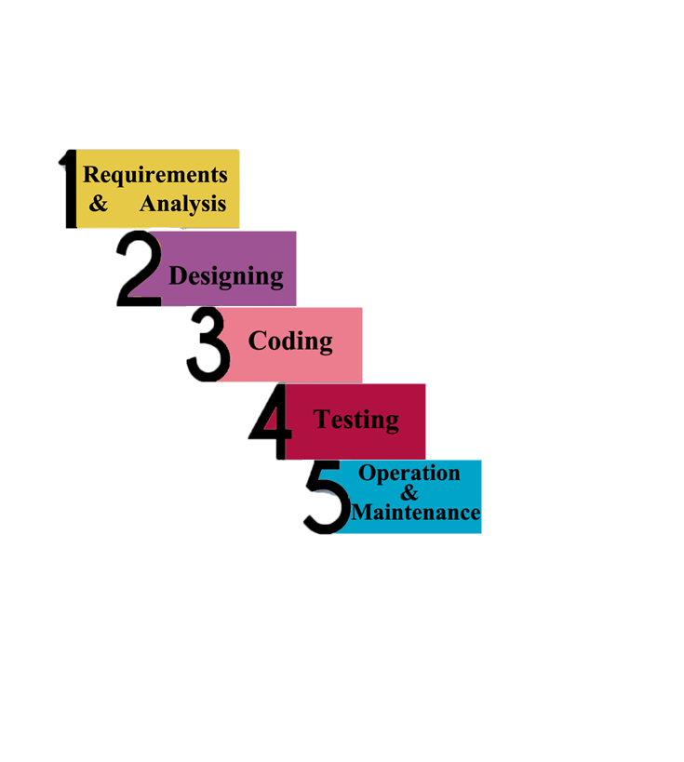

- Requirements gathering and analysis
- Software / project Design
- Coding
- Testing
- Operation & maintenance

Requirements gathering and analysis:

It is the first step of waterfall model. In this phase we have to understand the System requirement and actual need. In this phase information and detail must gather accurately. There should no ambiguities in requirement detail.
It is very important to understand the actual requirement of system and expectation so end product meets its specification.
In this process we have to understand the question that “what is going to developed and what specification it must contain”

Software / project Design:

The Requirements of the project given by user/customer/advisor are broken down into logical modules for implementation purpose. Software and hardware requirements are for every module are identified by designed accordingly. The inter relation between different logical module are established at this phase. Diagrams and algorithm defining the scope and objective of the project are also developed in this Designing phase. We can say that this phase lays a fundamental for actual programming and implementation.

Coding:

At this step design is translated into machine readable /understandable form. Coding efficiency directly related to well design. If your design is good your coding will be good accordingly.

Testing:

When coding get completed, in this stage the project/software are checked to ensure that it is free of errors. It is also checked to confirm that the software meet the desired needs. The software is test into two parts.
        - software (b) hardware
Hardware which are associated with this project/software are checked that it work smoothly or not over software.

Maintenance:

It is the final phase of Waterfall model. When the completed software is handed over to concern user, then it is the responsibility of software deployment team to carry out the routine maintenance task by visiting user site. If user want some changing in software, all the process will repeat from the first phase i.e. Requirement phase.
This is the longest phase of waterfall model. In this phase those error are to be correct which were not detected in the test phase.

1.7.2 Reasons for Chosen Methodology

Reasons for choosing the Methodology
The main idea for selection of this model is that to get the benefits of both these models. We will be deploying the linear nature of waterfall model here along with minimizing the risks through spiral model.
Combination of both waterfall and spiral model is called hybrid approach of system development that maximize the quality of system and minimize the disadvantages and risk. It generates complete and comprehensive documentation and hence makes the maintenance task much easier.

1.7.2 Work Plan (Gantt chart)

1.7.2 Project Schedule (Submission Calendar)

Project Schedule:

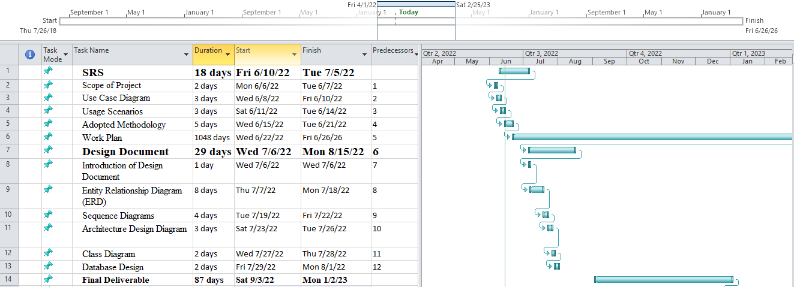

CHAPTER 2
Designing the Project

2.1 Introduction

Design is the abstraction of a solution. This document is designed to see what is to be built at its origin levels to give a software expansion team an overall guidance of the architecture of the software project. This phase surround ERD, Class diagram, Architecture design, Sequence diagram, Database diagram, Interface diagram and test cases.

2.2 purpose

The purpose of this document is to describe the implementation of the Shopify your products online described in the functional requirements.

2.3 scope

This document describes the implementation details of the Shopify your products online system. The website will consist of a two major functions. First to design therapies that is made up of tasks and the second to perform the therapies. This document will not specify any actual therapies or the testing of the software.

2.4 definitions, acronyms and abbreviations

An ERD is a logical representation of a system data. It consists of three primary components (Entities, Attributes and Relationships).

A class diagram is a type of static structure diagram that describes the structure of a system by showing the system's classes, their attributes, operations, and the relationships among objects.

Architecture design is an important phase of system design. It shows the system component in layer model.
A sequence diagram is an interaction diagram that show the detail operations of the system which system will be carried out. What messages are sent and when. Sequence diagrams are organized the system activity according to time.
Database design is the process of producing a detailed data model of a database. This logical data model contains all the needed logical and physical design choices and physical storage parameters needed to generate a design in a data definition language, which can then be used to create a database.
User interface diagram is the design of software applications which focus on the user's experience and interaction. The goal of user interface diagram is to make the user's communication with the software is simple and efficient as possible.
A test case is a set of conditions or variables under which system will determine.

2.5 Architectural Representation (Architecture Diagram)

Architecture Diagram basically show the whole Skelton of software application, it shows the Back End, Front End, and Major Portion Middle End. This business layer must be designed efficient to increase the efficiency of Application.

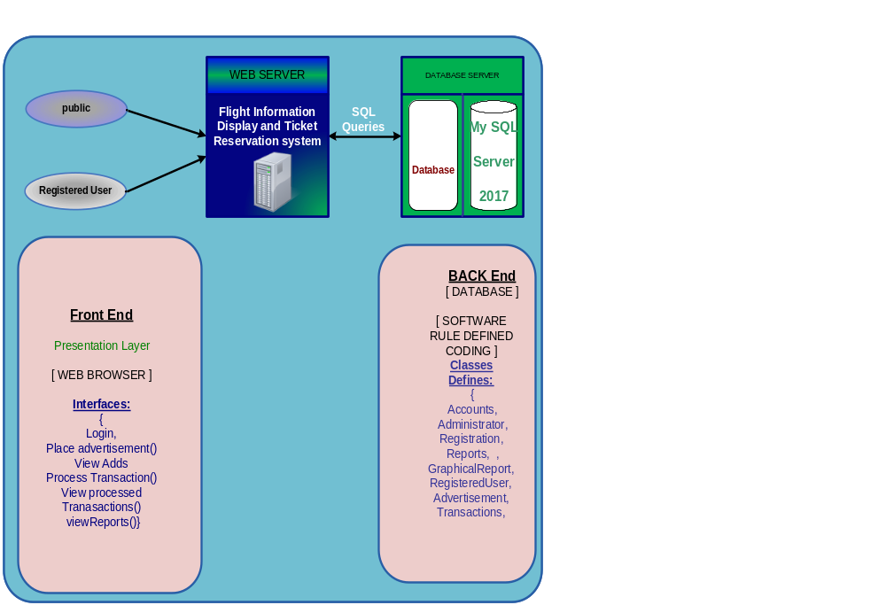

2.6 Dynamic Model: Sequence Diagrams

“Sequence diagrams model the flow of logic within your system in a visual manner, enabling you both to document and validate your logic, and are commonly used for both analysis and design purposes. Sequence diagrams are the most popular UML artifact for dynamic modeling, which focuses on identifying the behavior within your system...”

Create New Account
Application
Database
Un Registered User

Sign up ()

Okay
Account created successfully
Create Account
Login Admin or User
Application
Database
User / Admin

Sign in ()

Okay
Login to account successfully
Login to Account
User Management
Application
Database
Admin

Manage user ()

Okay
Users managed successfully
View/Add/Update/Delete Users
Product Management
Application
Database
Admin
Post Item ()

Okay
Product posted successfully
Add new Products with details
Orders Management
Application
Database
Admin
Orders ()

Okay
Record Updated successfully
Manage Customer Orders
Payment Management
Application
Database
Admin
Product Payment ()

Okay
Product Payment Received
Manage Payment Record

View Products Customer Side
Application
Database
Customer
Search item()

Okay
Search items successfully
Search Products with type
Selected Product Add to Cart List
Application
Database
Customer
Cart List ()

Okay
Selected Products list published successfully
Add to cart Selected Product
Checkout Product Record
Application
Database
Customer
Check out ()

Okay
Fill customer information for buy product
View products in cart list
Place Order Customer Management
Application
Database
Customer
Payment Method ()

Okay
Your Order Successfully Submit
Book Order for Selected Item

Customer Order Confirmation

Application
Database
Customer
Order Details ()

Okay
Your Payment has been Confirm
Order Confirmation

2.7 Object Model/Logical Model: Class Diagram

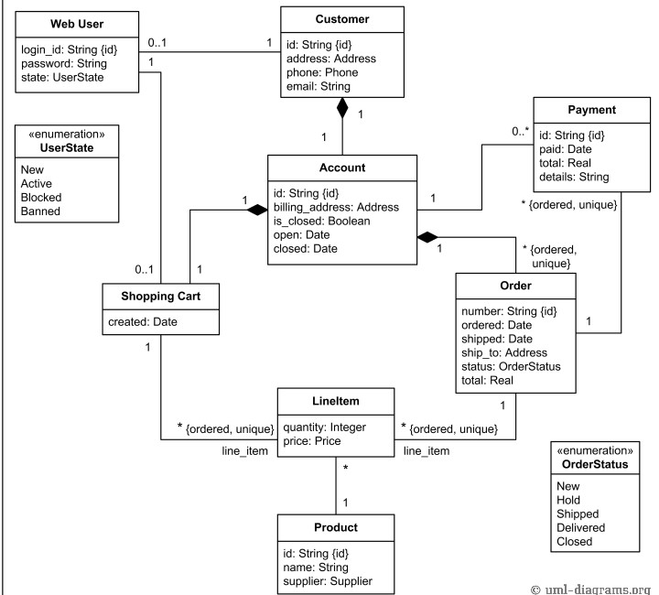

2.8 Database Model (Database Diagram)

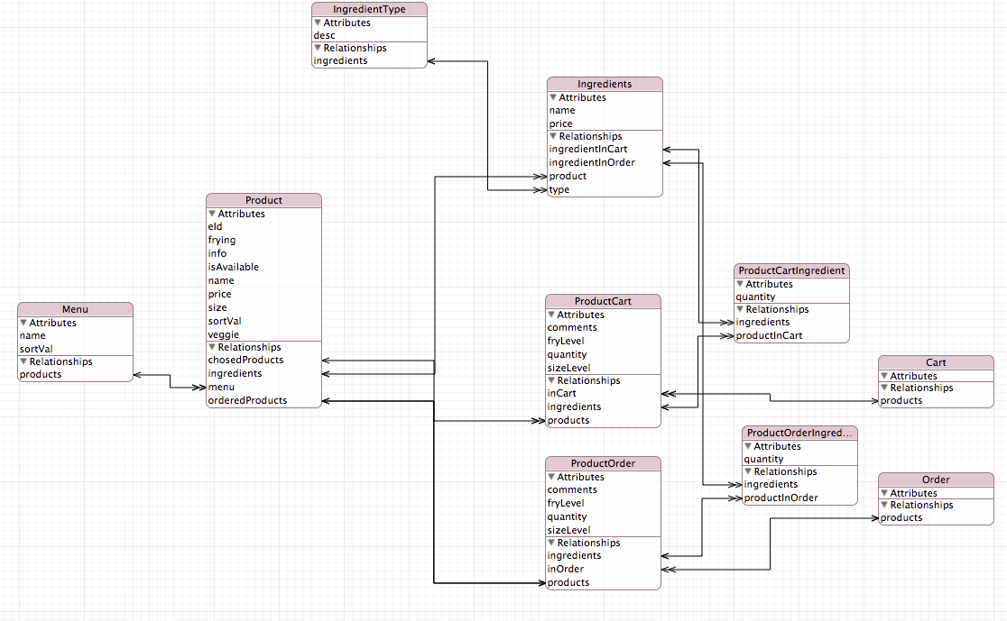

2.9 Graphical User Interfaces

Registration interface
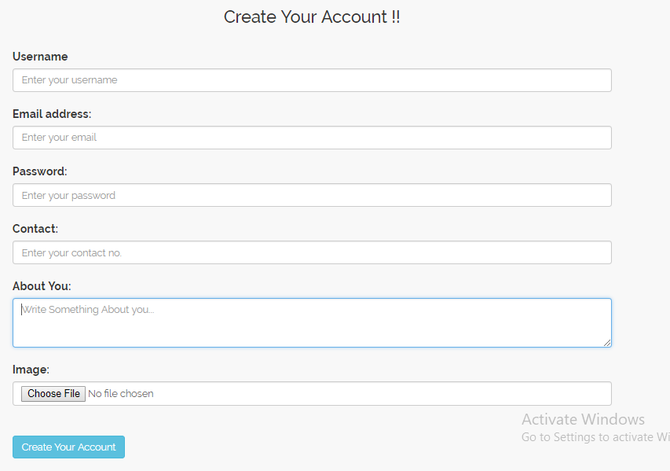

Login window

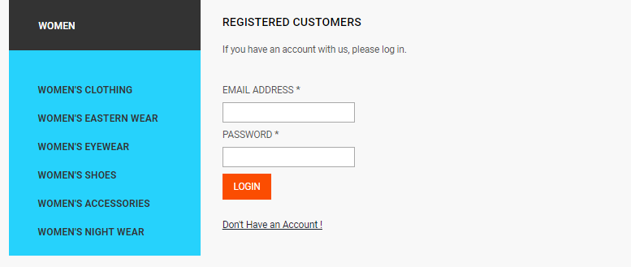

CHAPTER 3
Development

3.1 Development plan (Architecture Diagram)

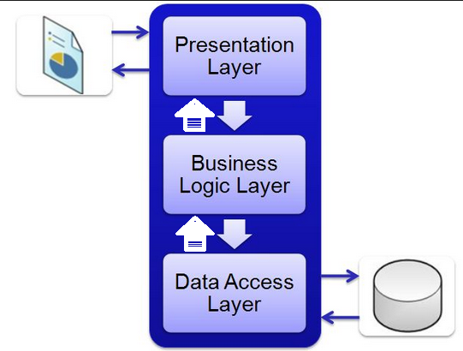
REFERENCES

- http://www.w3schools.com/
- http://urduitacademy.com/
- https://www.wikipedia.org/
- https://www.google.com.pk/imghp?hl=en&tab=wi
(Google images, for downloading of website logo and many other photos)

APPENDIX

I used the following books in the preparation of SRS and Design Documents.

- Cs 504 Software engineering I
- Cs605 Software engineering II
- Cs301 data structure

In order to learn coding, I consult the following books.

- CS201- Introduction to Programming
- Cs304 – Object Oriented Programming
- Cs403- Database Management System
- CS605- Software Engineering II
- CS506- Web Design and Development

